Java Playwright Architecture
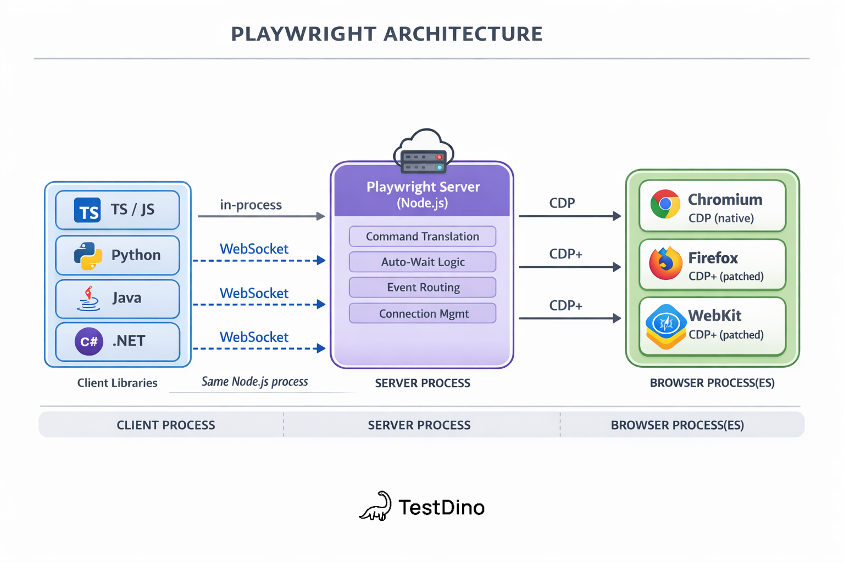
3 Layers Architecture
- Client Libraries (API to write tests using Java, Python, C#)
- Server Process (Translates API calls into browser specific protocol commands)
- Browser Processes (Execute commands and renders pages)
Playwright architecture follows client-server model where test script (client) communicates with a server process, which then controls browser engine through the Chrome DevTool Protocol (CDP).
Layer 1: Client Libraries
Playwright supports TypeScript/JavaScript, Python, Java and .Net (C#). Using these libraries, you write your tests.
Layer 2: Playwright Server (Core Engine)
This layer handles –
- Command translation: converting high level API calls like page.click() into low level messages
- Auto waiting logic: Checks element visibility, stability and actionability before executing actions
- Event routing: Streams browser events (page loads, network requests etc) back to you test
- Connection management: Maintains persistent connections to one or more browser instances
This layer maintains bidirectional connection to the browser instead of making HTTP requests for every action. It has built in auto-wait mechanism that verifies the element states (visible, enable, stable, enable etc)

Layer 3: Browser Engine
Playwright supports 3 browser engines:
Engine | What it powers | Playwright modification
Chromium | Chrome, Edge | Uses CDP natively, minimal patches
Firefox | Firefox | Custom protocol patches (CDP-like layer added by Playwright team)
WebKit | Safari | Custom protocol patches (CDP-like layer added by Playwright team)

Key Point Explanation:
- What is Bi-directional Websocket connection?
In Websocket connection, both server client and server can send and receive data at the same time over a single, persistent link. So in case of playwright, it is script i.e. client and the Playwright server or browser.
Playwright opens one persistent WebSocket connection instead of opening and closing HTTP connection for every single command.
Playwright Commands from script go to the browser and at the same time, browser may keep loading the page over the same TCP link.
Hence server or browser can push notifications instantly without the client constantly polling for updates

- How Playwright Built-In Auto waits work?
Whenever a Playwright command is run e.g. page.click(locator), it does not directly click the element. Instead it keeps polling bi-directionally. It check for every 100 milisec. Depending on the action is being taken, Playwright goes through specific checklist of element whether it is Attached, Visible, Stable, Enabled, Receives Events [runs a hit-test at the element's center coordinates to ensure it isn't covered or obscured by an overlapping element (such as a loading spinner, a transparent overlay, or a modal backdrop).].
Below are the checkpoints Playwright perform before taking any action
Action | Visible | Stable | Receives Events | Enabled | Editable
Locator.check() | Yes | Yes | Yes | Yes | -
Locator.click() | Yes | Yes | Yes | Yes | -
Locator.dblclick() | Yes | Yes | Yes | Yes | -
Locator.setChecked() | Yes | Yes | Yes | Yes | -
Locator.tap() | Yes | Yes | Yes | Yes | -
Locator.uncheck() | Yes | Yes | Yes | Yes | -
Locator.hover() | Yes | Yes | Yes | - | -
Locator.dragTo() | Yes | Yes | Yes | - | -
Locator.screenshot() | Yes | Yes | - | - | -
Locator.fill() | Yes | - | - | Yes | Yes
Locator.clear() | Yes | - | - | Yes | Yes
Locator.selectOption() | Yes | - | - | Yes | -
Locator.selectText() | Yes | - | - | - | -
Locator.scrollIntoViewIfNeeded() | - | Yes | - | - | -
Locator.blur() | - | - | - | - | -
Locator.dispatchEvent() | - | - | - | - | -
Locator.focus() | - | - | - | - | -
Locator.press() | - | - | - | - | -
Locator.pressSequentially() | - | - | - | - | -
Locator.setInputFiles() | - | - | - | - | -

- What is CDP (Chrome DevTool Protocol)?
CDP (Chrome DevTools Protocol) is the low-level messaging protocol that Playwright uses to control Chromium-based browsers. It sends JSON-formatted commands for navigation, DOM manipulation, network interception, and more.
Playwright's CDPSession API even lets you send raw CDP commands directly when you need low-level control:

Playwright Execution Flow
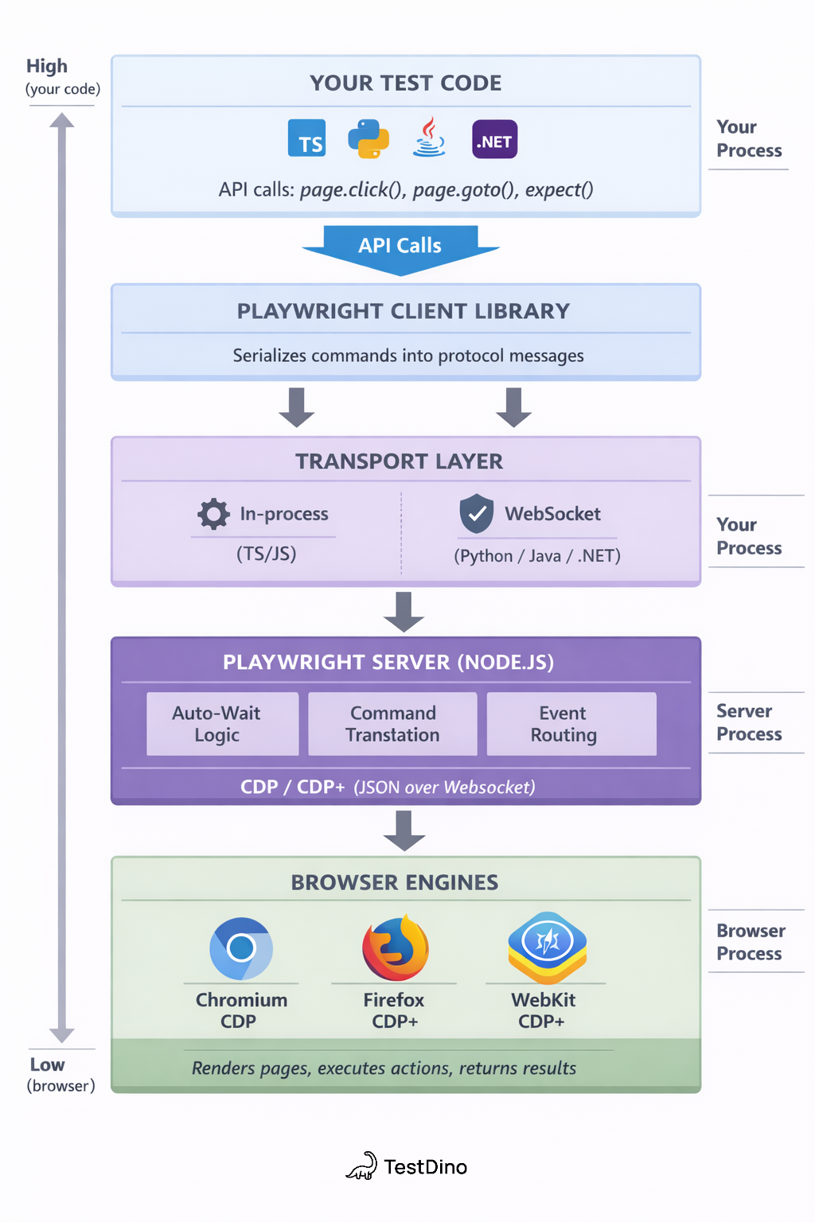
1. Layer 1: Java Client SDK When page.locator(“//button”).click() is called, at click() function, locator configuration is packed into JSON RPC 2.0 object
2. Layer 2: The Transport Layer Acts as a bridge between JVM runtime and Node.js engine. The Java SDK serializes the JSON RPC object into single line of raw text string which is then sent to Node.js driver server
3. Layer 3: Playwright Node.js Driver In this layer auto-waiting logic is run before performing any action
4. Layer 4: CDP When the element is ready to receive the actions, high level click is converted to low level device actions using browser native debugging protocol i.e. CDP
5. Layer 5: The Browser Engine Browser engine receives mouse event coordinates from CDP via WebSockets to the Browser engine

Playwright Architecture vs. Selenium Architecture
Feature | Playwright | Selenium
Primary Developer | Backed by Microsoft. | Open-source community.
Architecture | Direct browser control (Bi-directional WebSocket connection). | WebDriver protocol (HTTP request/response cycle).
Communication  Protocol | WebSocket + CDP | HTTP + WebDriver protocol
Speed & Performance | Extremely fast; handles asynchronous actions seamlessly. | Slower; throttled by HTTP round-trips.
Waiting Mechanism | Built-in Auto-wait (awaits element readiness out of the box). | Manual management (requires explicit, implicit, or fluent waits).
Supported Languages | JavaScript, TypeScript, Python, Java, and .NET. | Java, Python, C#, JavaScript, Ruby, and PHP.
Browser Support | Chromium (Chrome, Edge), Firefox, and WebKit (Safari engine). | Virtually all browsers, including legacy ones (e.g., Internet Explorer).
Parallel Execution | Built-in out of the box. | Requires Selenium Grid configuration.
Setup Complexity | Zero configuration; installs browsers automatically. | High; requires separate browser drivers matching local versions.
Tooling & Ecosystem | Built-in test runner, Trace Viewer, and Codegen generator. | Barebones automation; relies heavily on third-party frameworks (TestNG, JUnit).

Playwright Initialization Mechanism

- What is Playwright.create()
It is used to initialize the Playwright instance. Playwright is a class. The “create()” method launches new Playwright driver process and connects to it. These are Node.js processes. This is essential before launching a browser.

- What is Browser interface and launch() method?
This is similar to Selenium new ChromeDriver(). It is used to launch the browser. The chromium() includes Chrome and Edge. For Firefox browser there is firefox() and for Safari there is webkit(). By default Playwright launches browser in headless mode. Explicitly, it is needed to set headless as false using BrowserType.LaunchOptions().

- What is BrowserContext? Browser Vs. BrowserContext?
Browser is the actual browser instance while BrowserContext is isolated, incognito like browser session inside the Browser. A Browser can have multiple BrowserContexts and each BrowserContext can have multiple Pages (tabs)
- When we need to perform test isolated, newly logged in user go with BrowserContext

- What is Page?
Page is an interface that is used to open a tab in newly launched Browser. When “newPage” method is called, a new tab is opened in the already lauched Browser

